**To Scale up and Scale Down EC2**

**Step-1**

**Select instance for which you want to scale up or scale down**

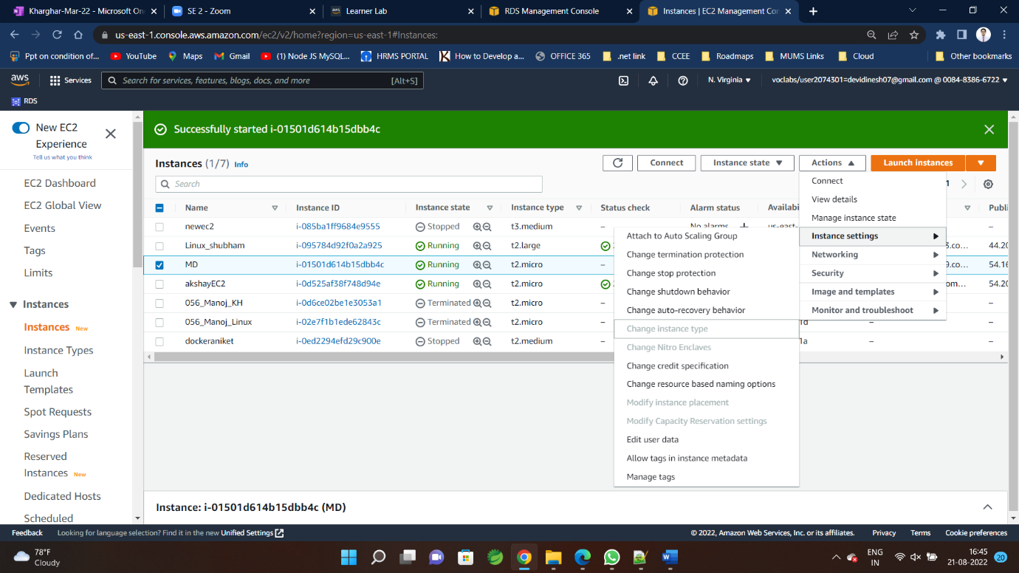

**It must be in stopped condition to get option for change instance type**

**Step-2**

**Click on Action 🡪 instance setting🡪 change instance type**

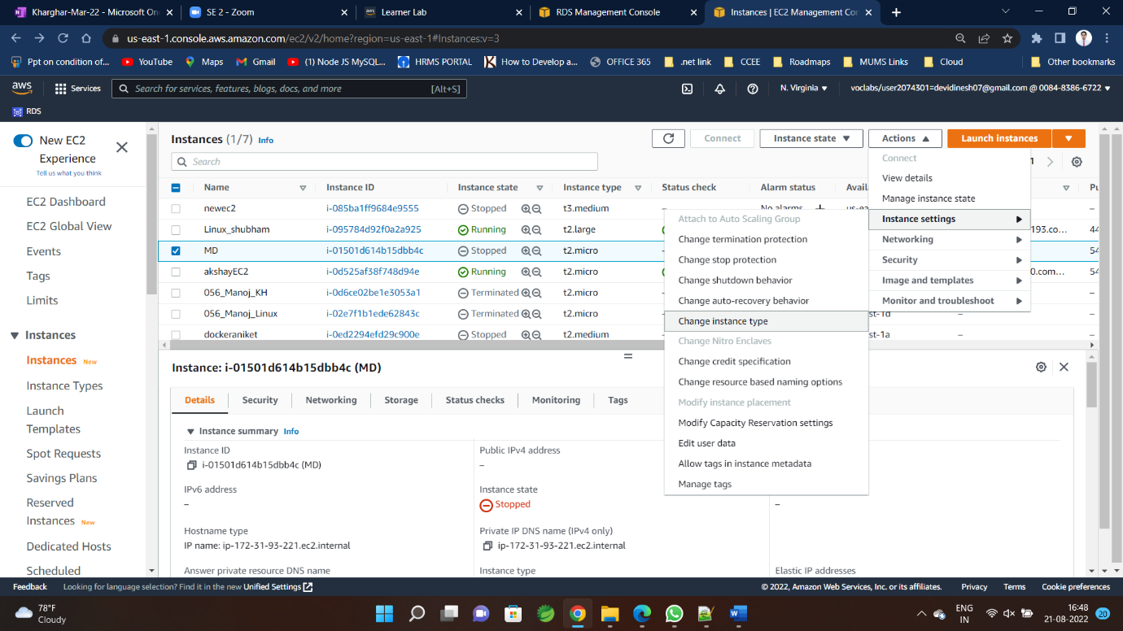

**Step-3**

**Select as per requirement and 🡪click apply**

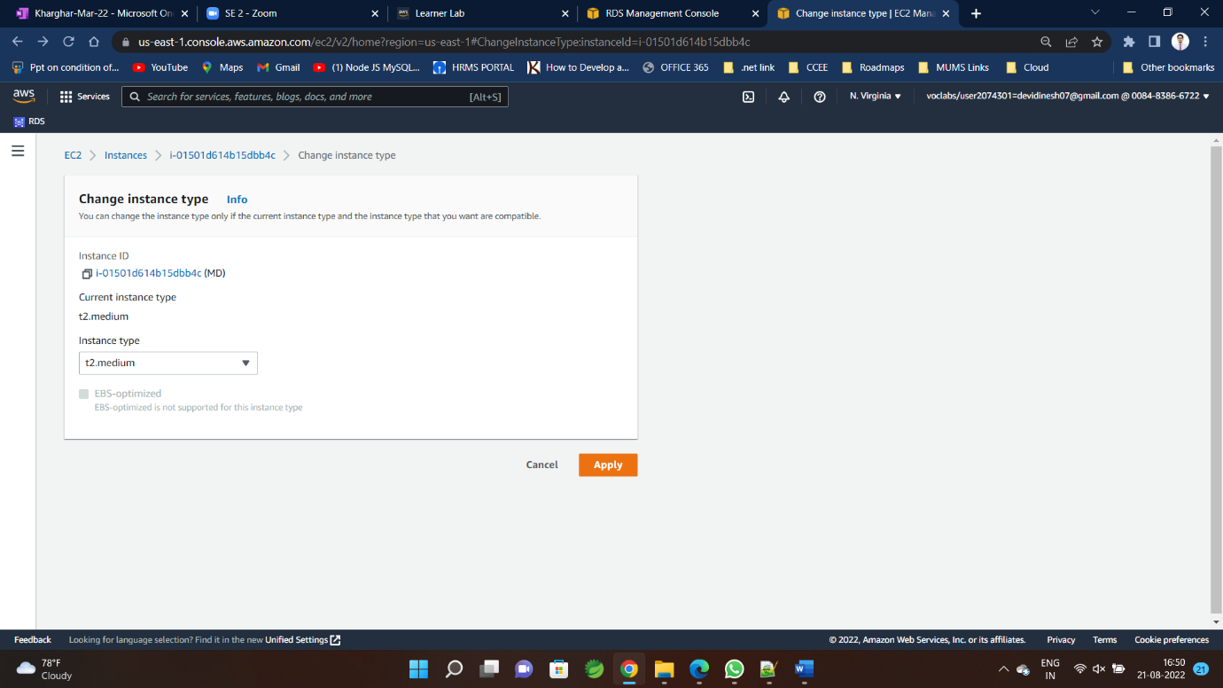

**Step-4**

**Similarly follow same step to step-down any EC2**